1. How should BiteSize use a CSS media query breakpoint to transform its multi-column layout into a mobile-friendly view?
Answer:
BiteSize should use a CSS media query breakpoint to change its desktop multi-column layout into a single-column layout on smaller screens. A media query allows CSS to apply different styles depending on the screen or viewport size (MDN Web Docs, 2026). This is an important part of responsive web design because a layout that works well on a large computer screen can become crowded and difficult to use on a smartphone.
For BiteSize, a breakpoint such as 768px can be used. When the screen width is 768px or smaller, the columns can be changed into one column. This allows the checkout information to appear vertically in a clear order instead of squeezing several columns onto the small screen.
Example CSS
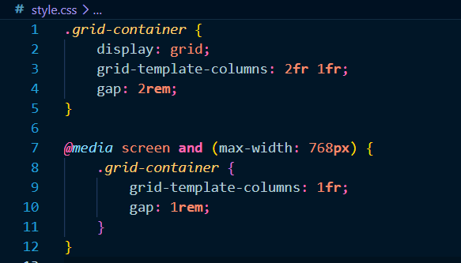
Here, the normal layout has two columns. When the viewport becomes 768px or smaller, the media query changes grid-template-columns to 1fr, meaning that the content takes up one column (MDN Web Docs, 2026). Using max-width in this way applies the mobile styles when the viewport is at or below the specified width.
Simple analogy
Think of a large dining table. On a large table, several dishes can be placed side by side. On a small table, putting everything side by side makes it crowded. Instead, you arrange the dishes in a single line.
The CSS media query does the same thing: it rearranges the website when the available space becomes smaller.
Real-life example
When a customer visits BiteSize on a laptop, the checkout could show the customer's information and order summary beside each other. When the same customer opens the website on a smartphone, the breakpoint automatically changes the layout so that each section appears one below another.
This approach is consistent with responsive design, where a narrow-screen layout is commonly changed to a simple single-column structure and wider screens can use multiple columns (MDN Web Docs, 2026).
The website should also include the viewport setting:
<meta name="viewport" content="width=device-width">
This helps mobile browsers use the actual device width so that the media query responds correctly to the phone's screen size.
Conclusion
Therefore, BiteSize can use a breakpoint such as 768px to detect smaller screens and change its multi-column layout into a single-column mobile layout. This reduces crowding, makes the checkout easier to read, and prevents users from having to scroll horizontally or interact with squeezed content. Media queries are specifically designed to apply different layouts according to viewport conditions.
References
MDN Web Docs. (2026). Media queries. Mozilla. https://developer.mozilla.org/en-US/docs/Web/CSS/Guides/Media_queries
World Wide Web Consortium. (2026). Media Queries Level 5. W3C. https://www.w3.org/TR/mediaqueries-5/

2. What specific HTML5 form input types and attributes will optimize their checkout fields for quick smartphone entry?
Answer
BiteSize should use specific HTML5 input types and attributes instead of using generic text fields for every checkout field (MDN Web Docs, 2026). These features make the checkout process easier on smartphones by providing appropriate virtual keyboards, supporting browser autofill, and providing basic form validation. HTML5 input types also help the browser understand what kind of information the customer is expected to ente.
For the BiteSize checkout form, type="email" should be used for the email field because it identifies the field as an email address and provides basic browser validation. The phone number should use type="tel" because it is specifically designed for telephone numbers. The form also uses inputmode="tel" for the phone field and inputmode="numeric" for the postal code and card number fields. The inputmode attribute gives the browser a hint about which virtual keyboard would be most useful for the user.
The autocomplete attribute is also important for mobile checkout. BiteSize uses values such as autocomplete="name", autocomplete="email", autocomplete="tel", autocomplete="street-address", autocomplete="postal-code", and autocomplete="cc-number". These values help the browser identify the purpose of each field and can allow saved information to be used to complete the form faster (WHATWG, 2026).
The required attribute is used for important checkout fields so that customers cannot submit the form while leaving required information empty. The placeholder attribute also provides a short example of what information should be entered, making the form easier to understand.
The HTML code used for BiteSize includes these mobile-friendly features:
Figure 1:
HTML code with mobile-friendly input types and attributes
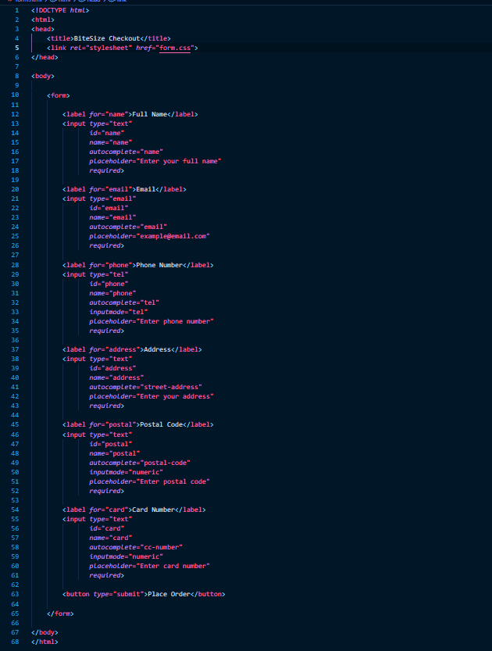
Note: This image shows shows the specific HTML5 features used to optimize smartphone entry.
Fields improve smartphone entry
Field | HTML5 feature | Purpose
Full Name | autocomplete="name" | Helps the browser autofill the name
Email | type="email" + autocomplete="email" | Supports email entry and validation
Phone | type="tel" + inputmode="tel" | Provides a telephone-friendly keyboard
Address | autocomplete="street-address" | Supports address autofill
Postal Code | inputmode="numeric" | Provides a numeric keyboard
Card Number | autocomplete="cc-number" + inputmode="numeric" | Supports payment autofill and numeric entry
Required fields | required | Prevents important fields from being left empty
All fields | placeholder | Gives users a short example of what to enter

Figure 2
CSS code for the responsive checkout form
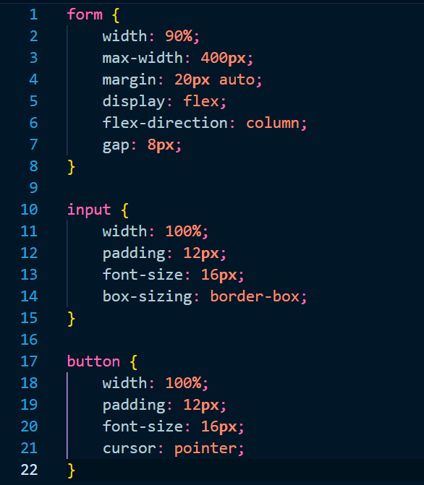
Note: This screenshot demonstrates that the form is styled to fit a smaller screen and that the fields are arranged vertically.
Figure 3
Mobile preview of the BiteSize checkout form
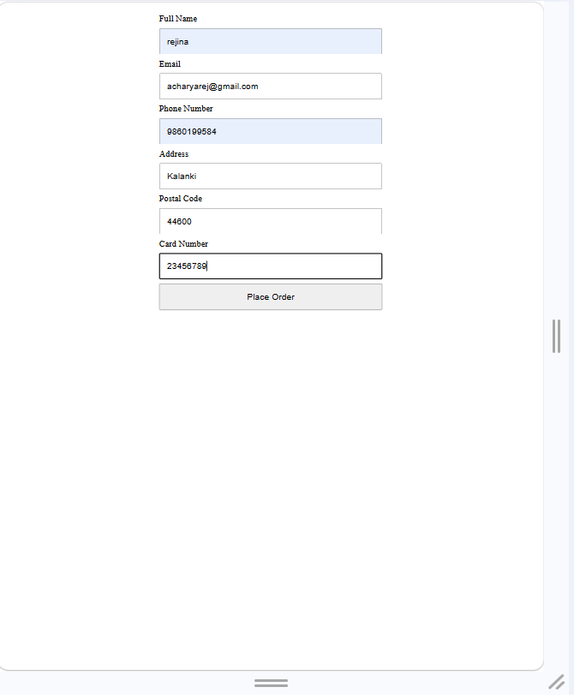
Conclusion
BiteSize should use appropriate HTML5 input types such as email and tel, along with attributes such as autocomplete, inputmode, required, and placeholder. These features help make the checkout process faster and easier on smartphones by supporting suitable virtual keyboards, browser autofill, and basic validation. The CSS then improves the visual layout by making the form fit smaller screens and making the fields easier to tap and use.
References
MDN Web Docs. (2026). <input>: The HTML input element. Mozilla.
WHATWG. (2026). HTML Standard: The input element. HTML Living Standard.

